27th November 2019

**Title: Dubai Duty Free Celebrates 48th UAE National Day**

**Summary:** Dubai Duty Free celebrated the UAE’s 48th National Day with all departments coming together for a programme of activities that were enjoyed by both Emiratis and their expat colleagues at the company’s Head Office in Umm Ramool.

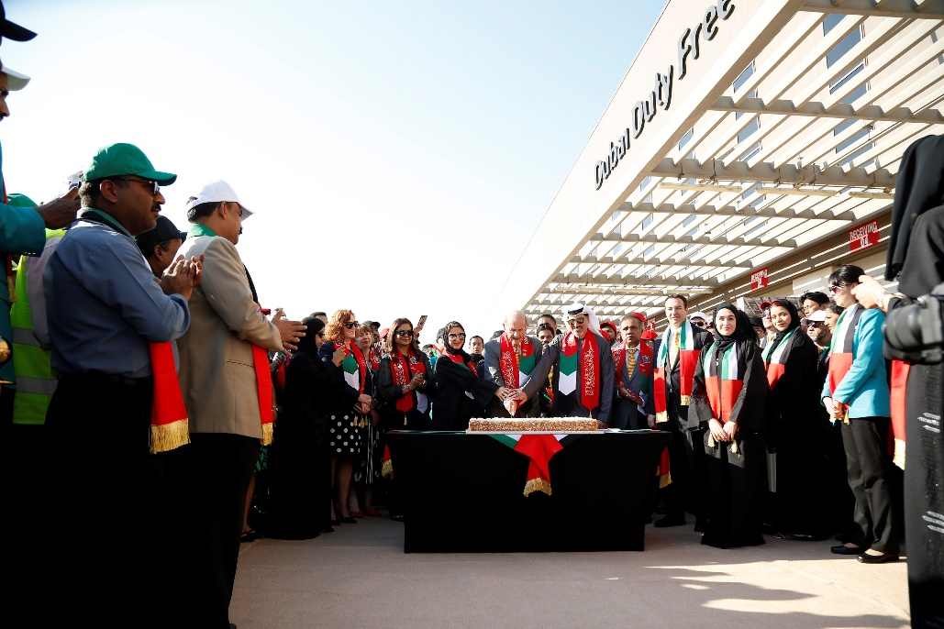

**Dubai Duty Free officials headed by Colm McLoughlin, Executive Vice Chairman & CEO at the ceremonial cake cutting for the UAE National Day celebration**

Dubai Duty Free celebrated the UAE’s 48th National Day with all departments coming together for a programme of activities that were enjoyed by both Emiratis and their expat colleagues at the company’s Head Office in Umm Ramool.

The celebrations were officially opened by the Executive Vice Chairman & CEO, Colm McLoughlin, and were commemorated with the UAE National Anthem.

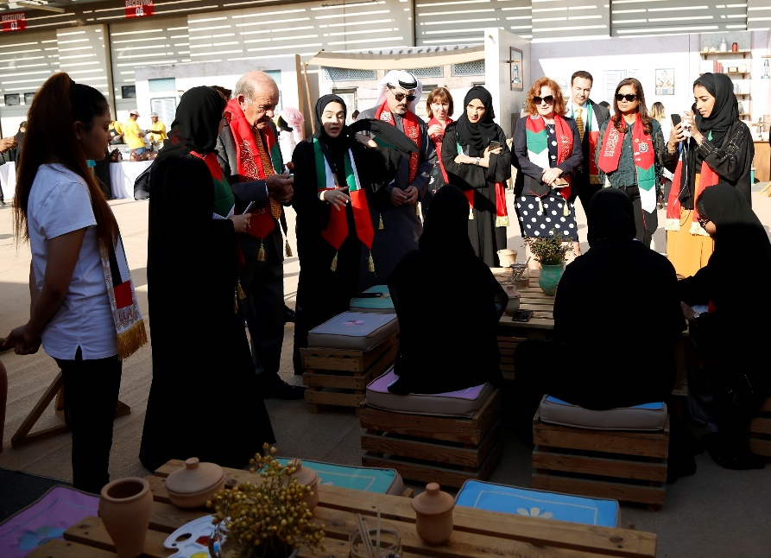

**Dubai Duty Free officials at the UAE National Day celebration**

As part of the celebrations, the Dubai Duty Free executives and employees enjoyed an outdoor Emirati exhibition on the grounds of the Dubai Duty Free Head Office. The exhibition showcased the UAE’s rich traditions and history and included attractions such as calligraphy, henna decoration, doll-making, pottery-painting and live cooking of traditional Emirati cuisine, all of which the employees actively participated before a cake-cutting ceremony.

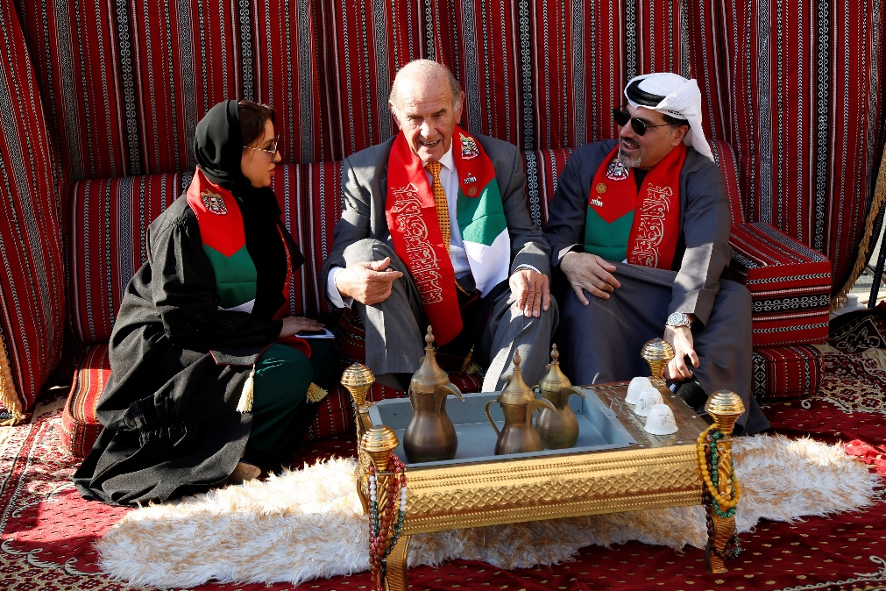

**Colm McLoughlin, Salah Tahlak, Executive Vice President - Corporate Services and Mona Al Ali, SVP-HR shares a lighter moment during the UAE National Day celebration**

Speaking on the occasion, McLoughlin said: “This special day in the UAE reflects its unity, strength and the nation’s rich culture. Our annual participation in the national day highlights our commitment to continuously supporting the UAE’s vision and plans, as well as to promote the spirit of camaraderie between our Emirati and expat employee.”

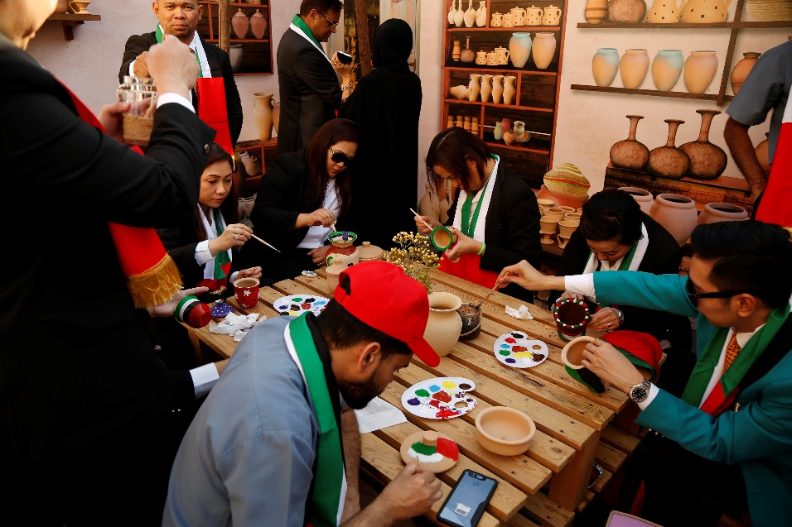

**Dubai Duty Free employee unleashed their artistic side through pottery painting**

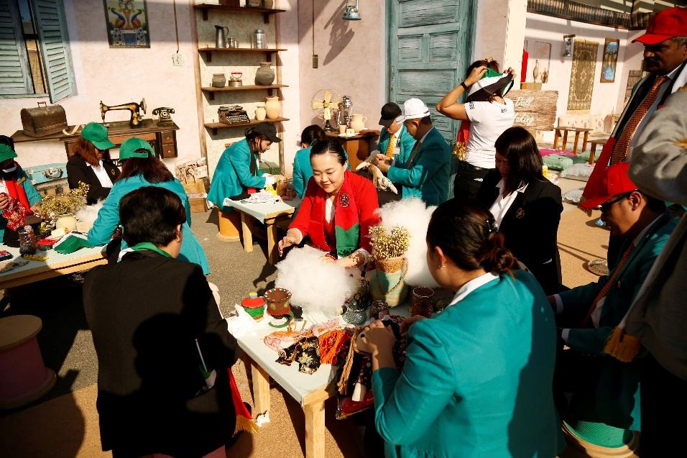

**Dubai Duty Free employees enjoys the doll making**

To mark the UAE National Day celebrations Dubai Duty Free announced a 20% discount offer across a wide range of products from 28th to 29th November at Dubai International Airport and Al Maktoum International Airport. The promotion applies to major categories including perfumes, cosmetics, watches, costume jewellery, precious jewellery, handbags, luggage, sunglasses, ladies, men's & children's fashion, confectionery and delicatessen.

* Ends –

For further information, please contact Bernard Aquino, Marketing Department,

Dubai Duty Free or call Tel: +9714-6019232 or email: [bernard.aquino@ddf.ae](mailto:bernard.aquino@ddf.ae)